WOMEN SAFETY

Real Time Project report

Submitted in partial fulfilment of the requirement for the award of the Degree of

Bachelor of Technology (B. Tech)

in

Computer Science and Engineering (AIML)

By

P.Manogna 22AG1A6647

Under the Esteemed Guidance of

Mr S.Venkatesh

Assistant Professor



Department of Computer Science and Engineering (AIML)

ACE ENGINEERING COLLEGE

AN AUTONOMOUS INSTITUTION

(NBA Accredited B.Tech Courses: ECE, EEE & CSE)

(Affiliated to Jawaharlal Nehru Technological University, Hyderabad, Telangana)

Ankushapur(V), Ghatkesar(M), Medchal- Malkajgiri Dist - 501 301.

JULY 2024.

 ACE

## ENGINEERING COLLEGE

AN AUTONOMOUS INSTITUTION

Website: www.aceec.ac.in E-mail: info@aceec.ac.in

CERTIFICATE

This is to certify that the Real Time Project work entitled “WOMEN SAFETY” is being submitted by P.Manogna(22AG1A6647),K.Manasa(23AG1A56606) in partial fulfilment for the award of Degree of BACHELOR OF TECHNOLOGY in DEPARTMENT OF COMPUTER SCIENCE ENGINEERING (AIML) to the Jawaharlal Nehru Technological University, Hyderabad is a record of Bonafide work carried out by her under our guidance and supervision

.

The results embodied in this project have not been submitted by the student to any other University or Institution for the award of any Degree or Diploma.

Internal Guide Head of the Department

Mr S.Venkatesh Dr S. Kavitha

Assistant Professor Assoc. Professor and

Head Dept. of CSE(AIML)

ACE ENGINEERING COLLEGE

ACKNOWLEDGEMENT

I would like to express my gratitude to all the people behind the screen who have helped me transform an idea into a real time application.

I would like to express my heart-felt gratitude to my parents without whom I would not have been privileged to achieve and fulfil my dreams.

A special thanks to our General Secretary, Prof. Y. V. Gopala Krishna Murthy, for having founded such an esteemed institution . I am also grateful to our beloved principal, Dr. B. L. RAJU for permitting me to carry out this project.

I profoundly thank Dr. S. Kavitha, Associate Professor and Head of the Department of Computer Science and Engineering (AIML), who has been an excellent guide and also a great source of inspiration to my work.

I extremely thank Mrs. J Bhargavi, Assistant Professor, Project coordinator, who helped me in all the way in fulfilling of all aspects in completion of my Real Time Project.

I am very thankful to my internal guide, Mr S.Venkatesh, Assistant Professor who has been an excellent and also given continuous support for the Completion of my project work.

The satisfaction and euphoria that accompany the successful completion of the task would be great, but incomplete without the mention of the people who made it possible, whose constant guidance and encouragement crown all the efforts with success. In this context, I would like to thank all the other staff members, both teaching and non-teaching, who have extended their timely help and eased my task.

## 

P.Manogna 22AG1A6647

Department of Computer Science and Engineering(AIML) i

ACE ENGINEERING COLLEGE

ABSTRACT

Women safety is a very important issue due to rising crimes against women these days. Presently there indeed no good solution to this problem. The existing applications and devices are not much effective as they need lot of human interaction to operate . These existing devices use to read the human temperature and heartbeat to generate alarm in case of emergency. When a person runs, every human may have different body temperature and heartbeat pattern and thus keeping a fixed threshold for finding out emergency situation and then generating alarm is not correct way and is where the existing devices are failing to correctly generate alarm in case of emergency . In this pape rthe devices are customized to learn the individual pattern of temperature and heartbeat and then finds out the threshold for generating alarm. Thus this paper deals to design a wearable women safety device that automatically reads and create patterns such as body temperature and pulse rate during running. If readings are higher than the normal readings then it will automatically call and message more than one person along with the location so that actions can be taken . We have used temperature and pulse sensors that will detect the activity of the woman and that data of sensors will be sent to cloud where machine learning algorithm (logistic regression) is applied to analyse data generated. The data is first collected by sensors in non-danger conditions to train the algorithm after that data is used for testing to gauge the accuracy and how close it is to our trained data. More is the accuracy more is the surety of danger and the emergency alarm will be there on emergency contacts . Thirdly , this paper deals with scenarios where there is no internet facility. To overcome the problem of internet we have used ZigBee mesh network, which helped the device to send the data to multiple hop distance.

Department of Computer Science and Engineering(AIML) ii

ACE ENGINEERING COLLEGE

INDEX

CONTENTS PAGE NO

1.INTRODUCTION 1

2.PROFILE OF THE PROGRAM 2

2.1.Project Purpose 2

2.2.Existing projects 3

2.3.Drawbacks of existing system 3

3.PROBLEM ANALYSIS 4

3.1.Feasibility Analysis 4

3.2.Technical Feasibility 5

3.3.Operational Feasibility 5

3.4.Economical Feasibility 6

4.PROJECT PLANNING 7

5.SOFTWARE REQUIREMENT ANALYSIS 10

6.DESIGNING OF THE PROJECT 13

6.1.System Design 14

6.1.1.Use Case Diagram 15

Department of Computer Science and Engineering(AIML) iii

ACE ENGINEERING COLLEGE

6.1.2.Sequence Diagram 16

6.1.3.Class Diagram 17

6.2.Flow Charts 18

7.TESTING 21

7.1.Functional Testing 22

7.2.Structural Testing 23

8.IMPLEMENTATION 24

9.USER MANUAL 26

10.APPENDIX 28

Department of Computer Science and Engineering(AIML) iv

ACE ENGINEERING COLLEGE

LIST OF FIGURES

Fig. No. Figure Name PageNo.

6.1.1 Use Case Diagram 15

6.1.2 State Diagram 16

6.1.3 Class Diagram 17

6.2.1 Flow chart-Track me 18

6.2.2 Flow chart-Where are you? 19

6.2.3 Flow chart-Distress signals(SOS) 20

Department of Computer Science and Engineering(AIML) vi

ACE ENGINEERING COLLEGE

CHAPTER 1

INTRODUCTION

According to statistics, around **736 million** women worldwide have been victims of physical and sexual intimate violence, either by a partner or a non-partner. This staggering number accounts for one-third of all women globally, highlighting an urgent need for solutions to enhance their safety. In this context, the development of women’s safety apps has become crucial to empowering women to feel protected and safe, especially when they are out and about. Fortunately, such apps already exist in the market. In this blog, we will delve into everything about these apps, focusing on Women’s Safety App Development and how it contributes to addressing this critical issue.

At the global level, the Safer Cities Programme undertakes advocacy on local crime and violence prevention, policy development on human settlements and on the governance dimensions of crime and violence prevention, documents and analyses experiences, and develops and disseminates tools for local governments and other actors. Among key outputs are an integrated set of tools and resources on crime prevention, policy documents on key issues such as women’s safety, youth at risk and the role of the police in urban governance, regional strategies on youth at risk, and an overall increased recognition of the key role of crime prevention in sustainable human settlements development promoting inclusive cities.

Department of Computer Science and Engineering(AIML) 1

ACE ENGINEERING COLLEGE

CHAPTER 2

PROFILE OF THE PROGRAM

In a project report focused on women safety, the program profile typically includes detailed information about the program itself.

**Program Overview**: A brief description of the program, its objectives, and its intended impact on women's safety.

**Target Audience**: Who the program is designed to serve or benefit (e.g., women of all ages, specific communities, etc.).

**Implementation Plan**: How the program is structured and organized, including timelines, roles and responsibilities of stakeholders, and logistical details.

2.1.PROJECT PURPOSE

The purpose of a project in a women's safety report typically revolves around addressing and improving various aspects related to the safety and well-being of women.

• **Prevention of Violence**: Many women's safety projects focus on preventing various forms of violence against women, such as domestic violence, sexual harassment, and assault.

• **Awareness and Education**: Projects often aim to raise awareness among women and communities about their rights, available support services, and ways to stay safe.

Department of Computer Science and Engineering(AIML) 2

ACE ENGINEERING COLLEGE

2.2.Existing projects

There are several existing projects and initiatives focused on women's

safety around the world. These projects vary widely in scope, approach, and

geographical focus. Here are some examples:

1. **bSafe**: This app allows users to set up a network of "guardians" who can

be alerted in case of an emergency.

1. **My Safetipin**: This app provides safety information about neighborhoods

based on user reviews and evaluations.

1. **Life360**: While not exclusively for women's safety, Life360 allows users to create private groups (called "Circles") where family members or friends can check in with each other and receive alerts.

2.3.Drawbacks of existing system

**Reliance on Technology**: Women safety apps depend heavily on the

availability of network coverage and smartphone battery life.

**Response Time and Effectiveness**: While some apps promise to

connect users quickly with emergency services or contacts, the actual

response time can vary depending on factors such as the availability of

emergency personnel, local protocols, and the accuracy of location

tracking.

Department of Computer Science and Engineering(AIML) 3

ACE ENGINEERING COLLEGE

CHAPTER 3

PROBLEM ANALYSIS

When conducting a problem analysis in a women safety project, it's essential to thoroughly assess various aspects that contribute to the issue of women's safety.

• **Scope and Context**: Understand the specific geographical, cultural, and social contexts where women safety is a concern. Different regions may have varying levels of safety risks influenced by factors such as urbanization, economic conditions, cultural norms, and legal frameworks.

• **Incidence and Types of Violence**: Gather data on the prevalence and types of violence women face, including domestic violence, sexual harassment, assault in public spaces, trafficking, and online harassment. Analyze trends over time to identify patterns and areas of heightened risk.

• **Stakeholder Perspectives**: Engage with diverse stakeholders, including women survivors, community leaders, law enforcement officials, healthcare providers, policymakers, and NGOs working in the field. Understand their perspectives on challenges, priorities, and opportunities for improving women's safety.

3.1.Feasibility Analysis

Feasibility analysis in a women safety project involves evaluating various factors to determine the practicality and likelihood of success of proposed interventions or initiatives aimed at enhancing women's safety.

**Needs Assessment**: Begin by identifying and analyzing the specific safety needs and challenges faced by women in the target community or area. This involves gathering data on the prevalence and types of violence, existing support services, legal frameworks, and socio-economic factors influencing women's safety.

**Department of Computer Science and Engineering(AIML) 4**

**ACE ENGINEERING COLLEGE**

3.2.Technical Feasibility

Evaluate the technological aspects of proposed solutions, such as women safety apps, infrastructure improvements (like better lighting or CCTV installation), or digital platforms for reporting incidents.

• I**nfrastructure Requirements**: Evaluate the existing infrastructure related to communication networks (internet and mobile coverage), electricity supply (for lighting and technology), and transportation (for accessibility to services and emergency response).

• **Technology Solutions**: Assess the feasibility of technology-based solutions such as women safety apps, wearable devices, GPS tracking systems, and surveillance cameras. Consider factors like the availability of reliable hardware and software, compatibility with existing systems, and ease of integration.

• **Data Collection and Management**: Evaluate mechanisms for collecting, storing, and managing data related to incidents of violence against women. Ensure compliance with data privacy regulations and protocols to protect sensitive information.

3.3.Operational Feasibility

Operational feasibility in a women safety project assesses whether the proposed interventions or strategies can be implemented effectively within the operational constraints of the target area or community.

**Resource Availability**: Evaluate the availability of human resources (trained personnel, volunteers) and physical resources (facilities, equipment) needed to implement the women safety project.

**Logistical Support**: Assess the logistical feasibility of implementing the project, including transportation for personnel and supplies, access to communication networks, and infrastructure support for deploying interventions (such as installing safety equipment or setting up safe spaces).

Department of Computer Science and Engineering(AIML) 5

ACE ENGINEERING COLLEGE

3.4.Economical Feasibility

Economic feasibility in a women safety project involves evaluating the financial aspects of proposed interventions to ensure they are viable and sustainable.

**Cost of Implementation**: Evaluate the initial costs required to implement the women safety project. This includes expenses such as infrastructure development (e.g., installing lighting).

**Budget Allocation**: Determine how funds will be allocated across different aspects of the project, such as training programs, emergency response systems, awareness campaigns, and maintenance.

**Funding Sources**: Identify potential sources of funding, including government grants, private donations, corporate sponsorships, and community contributions.

**Risk Assessment**: Evaluate financial risks associated with the project, such as unexpected costs, changes in funding availability, or economic fluctuations.

**Monitoring and Evaluation**: Implement mechanisms to monitor financial performance and evaluate the economic impact of the project regularly. Adjust strategies as needed based on these assessments.

Department of Computer Science and Engineering(AIML) 6

ACE ENGINEERING COLLEGE

CHAPTER 4

PROJECT PLANNING

Planning a women's safety project involves several key steps to ensure effectiveness and sustainability.

### **Needs Assessment and Goal Definition:**

* **Identify Needs:** Conduct thorough research and surveys to understand the specific safety concerns faced by women in the target area or community.
* **Set Goals:** Clearly define the objectives of the project. These could include reducing incidents of violence, increasing awareness, improving access to support services, etc.

### **Stakeholder Engagement:**

* **Identify Stakeholders:** Determine who will be impacted by or involved in the project, such as community members, local authorities, NGOs, businesses, etc.
* **Consultation:** Hold meetings, focus groups, or interviews to gather input and ensure that the project addresses the needs and priorities of stakeholders

### **Strategy Development:**

* **Develop Strategies:** Based on the needs assessment and stakeholder input, create a detailed plan outlining how the goals will be achieved.

Department of Computer Science and Engineering(AIML) 7

ACE ENGINEERING COLLEGE

* **Types of Strategies:** This may include infrastructure improvements, training programs for women and law enforcement, awareness campaigns, setting up safe spaces, etc.

### **Resource Planning:**

* **Human Resources:** Identify and allocate roles and responsibilities to team members or volunteers involved in the project.
* **Financial Resources:** Develop a budget that covers all necessary expenses, including personnel costs, materials, technology, marketing, etc.
* **Material Resources:** Determine what physical resources (e.g., equipment, facilities) are required for implementation.

### **Implementation Plan:**

* **Timeline:** Create a timeline or schedule that outlines key milestones and deadlines for different project phases.
* **Coordination:** Establish communication channels and coordination mechanisms among project team members and stakeholders.
* **Risk Management:** Identify potential risks (e.g., funding shortfalls, logistical challenges) and develop strategies to mitigate them.

Department of Computer Science and Engineering(AIML) 8

ACE ENGINEERING COLLEGE

### 

### **Monitoring and Evaluation:**

* **Monitoring:** Implement systems to track progress towards goals and assess the effectiveness of activities.
* **Evaluation:** Conduct periodic evaluations to measure outcomes and impact. Use findings to make necessary adjustments and improvements to the project.

Department of Computer Science and Engineering(AIML ) 9

ACE ENGINEERING COLLEGE

CHAPTER 5

SOFTWARE REQUIREMENT ANALYSIS

Software requirement analysis for a women's safety project involves identifying, documenting, and managing the functional and non-functional requirements that software solutions need to fulfill.

### Gather Requirements:

* **User Interviews and Surveys:** Engage with stakeholders such as women at risk, law enforcement, community leaders, and NGOs to understand their needs and expectations.
* **Use Case Analysis:** Identify typical scenarios and use cases where software solutions could enhance safety, such as emergency response, real-time tracking, or communication.
* **Existing Systems Review:** Evaluate any existing software or systems being used and gather feedback on their strengths and weaknesses.

### **Define Functional Requirements:**

* **Emergency Response:** Specify functionalities like panic buttons, automatic alerts to authorities or designated contacts, and location tracking during emergencies.

Department of Computer Science and Engineering(AIML) 10

ACE ENGINEERING COLLEGE

* **Information and Awareness:** Include features for disseminating safety information, access to resources like helplines, legal information, and community support networks.
* **Reporting and Monitoring:** Define capabilities for incident reporting, tracking incidents over time, and generating statistical reports.

### **Specify Non-Functional Requirements:**

* **Performance:** Define response time requirements for emergency alerts and system availability.
* **Security:** Specify security measures such as data encryption, access control, and protection against unauthorized access.
* **Usability:** Ensure the software is intuitive and accessible to users of varying technical proficiency and language abilities.

### **Prioritize Requirements:**

* **Criticality:** Prioritize requirements based on their criticality to achieving project goals and addressing safety concerns effectively.
* **Feasibility:** Consider the feasibility of implementing each requirement within budget and time constraints.

Department of Computer Science and Engineering(AIML) 11

ACE ENGINEERING COLLEGE

### **Document Requirements:**

* **Use Cases:** Document detailed use cases describing how users interact with the software in various scenarios.
* **Requirements Specifications:** Create formal requirement documents that outline each requirement, its rationale, acceptance criteria, and any dependencies.

### **Validate and Verify Requirements:**

* **Validation:** Validate requirements with stakeholders to ensure they accurately reflect user needs and expectations.
* **Verification:** Verify that requirements are consistent, complete, and feasible given technological and resource constraints.

### **Iterative Review and Refinement:**

* **Iterative Process:** Review and refine requirements iteratively based on feedback, changing project needs, and emerging technologies.

### **Documentation and Handover:**

* **Documentation:** Maintain updated documentation throughout the development process for reference and future maintenance.
* **Handover:** Ensure a smooth transition of the developed software to operational teams, providing training and support as necessary

Department of Computer Science and Engineering(AIML) 12

ACE ENGINEERING COLLEGE

CHAPTER 6

DESIGNING OF THE PROJECT

Designing a women's safety project involves creating a comprehensive plan that addresses the specific safety concerns of women in a community or region.

### **Needs Assessment:**

* **Identify Safety Concerns:** Conduct surveys, interviews, and focus groups to understand the safety issues faced by women in the target area. This could include concerns related to physical safety, harassment, access to resources, etc.
* **Stakeholder Engagement:** Involve key stakeholders such as women's groups, community leaders, law enforcement, healthcare providers, and local authorities to gather diverse perspectives and insights.

### **Goal Setting:**

* **Define Objectives:** Based on the needs assessment, establish clear and measurable goals for the project . These goals should be specifi , achievable, relevant, and time-bound (SMART criteria).

Department of Computer Science and Engineering(AIML) 13

ACE ENGINEERING COLLEGE

6.1.System Design

Designing the system architecture for a women's safety project involves structuring the technical components and functionalities required to achieve project goals effectively and securely

6.1.1.Use Case Diagram

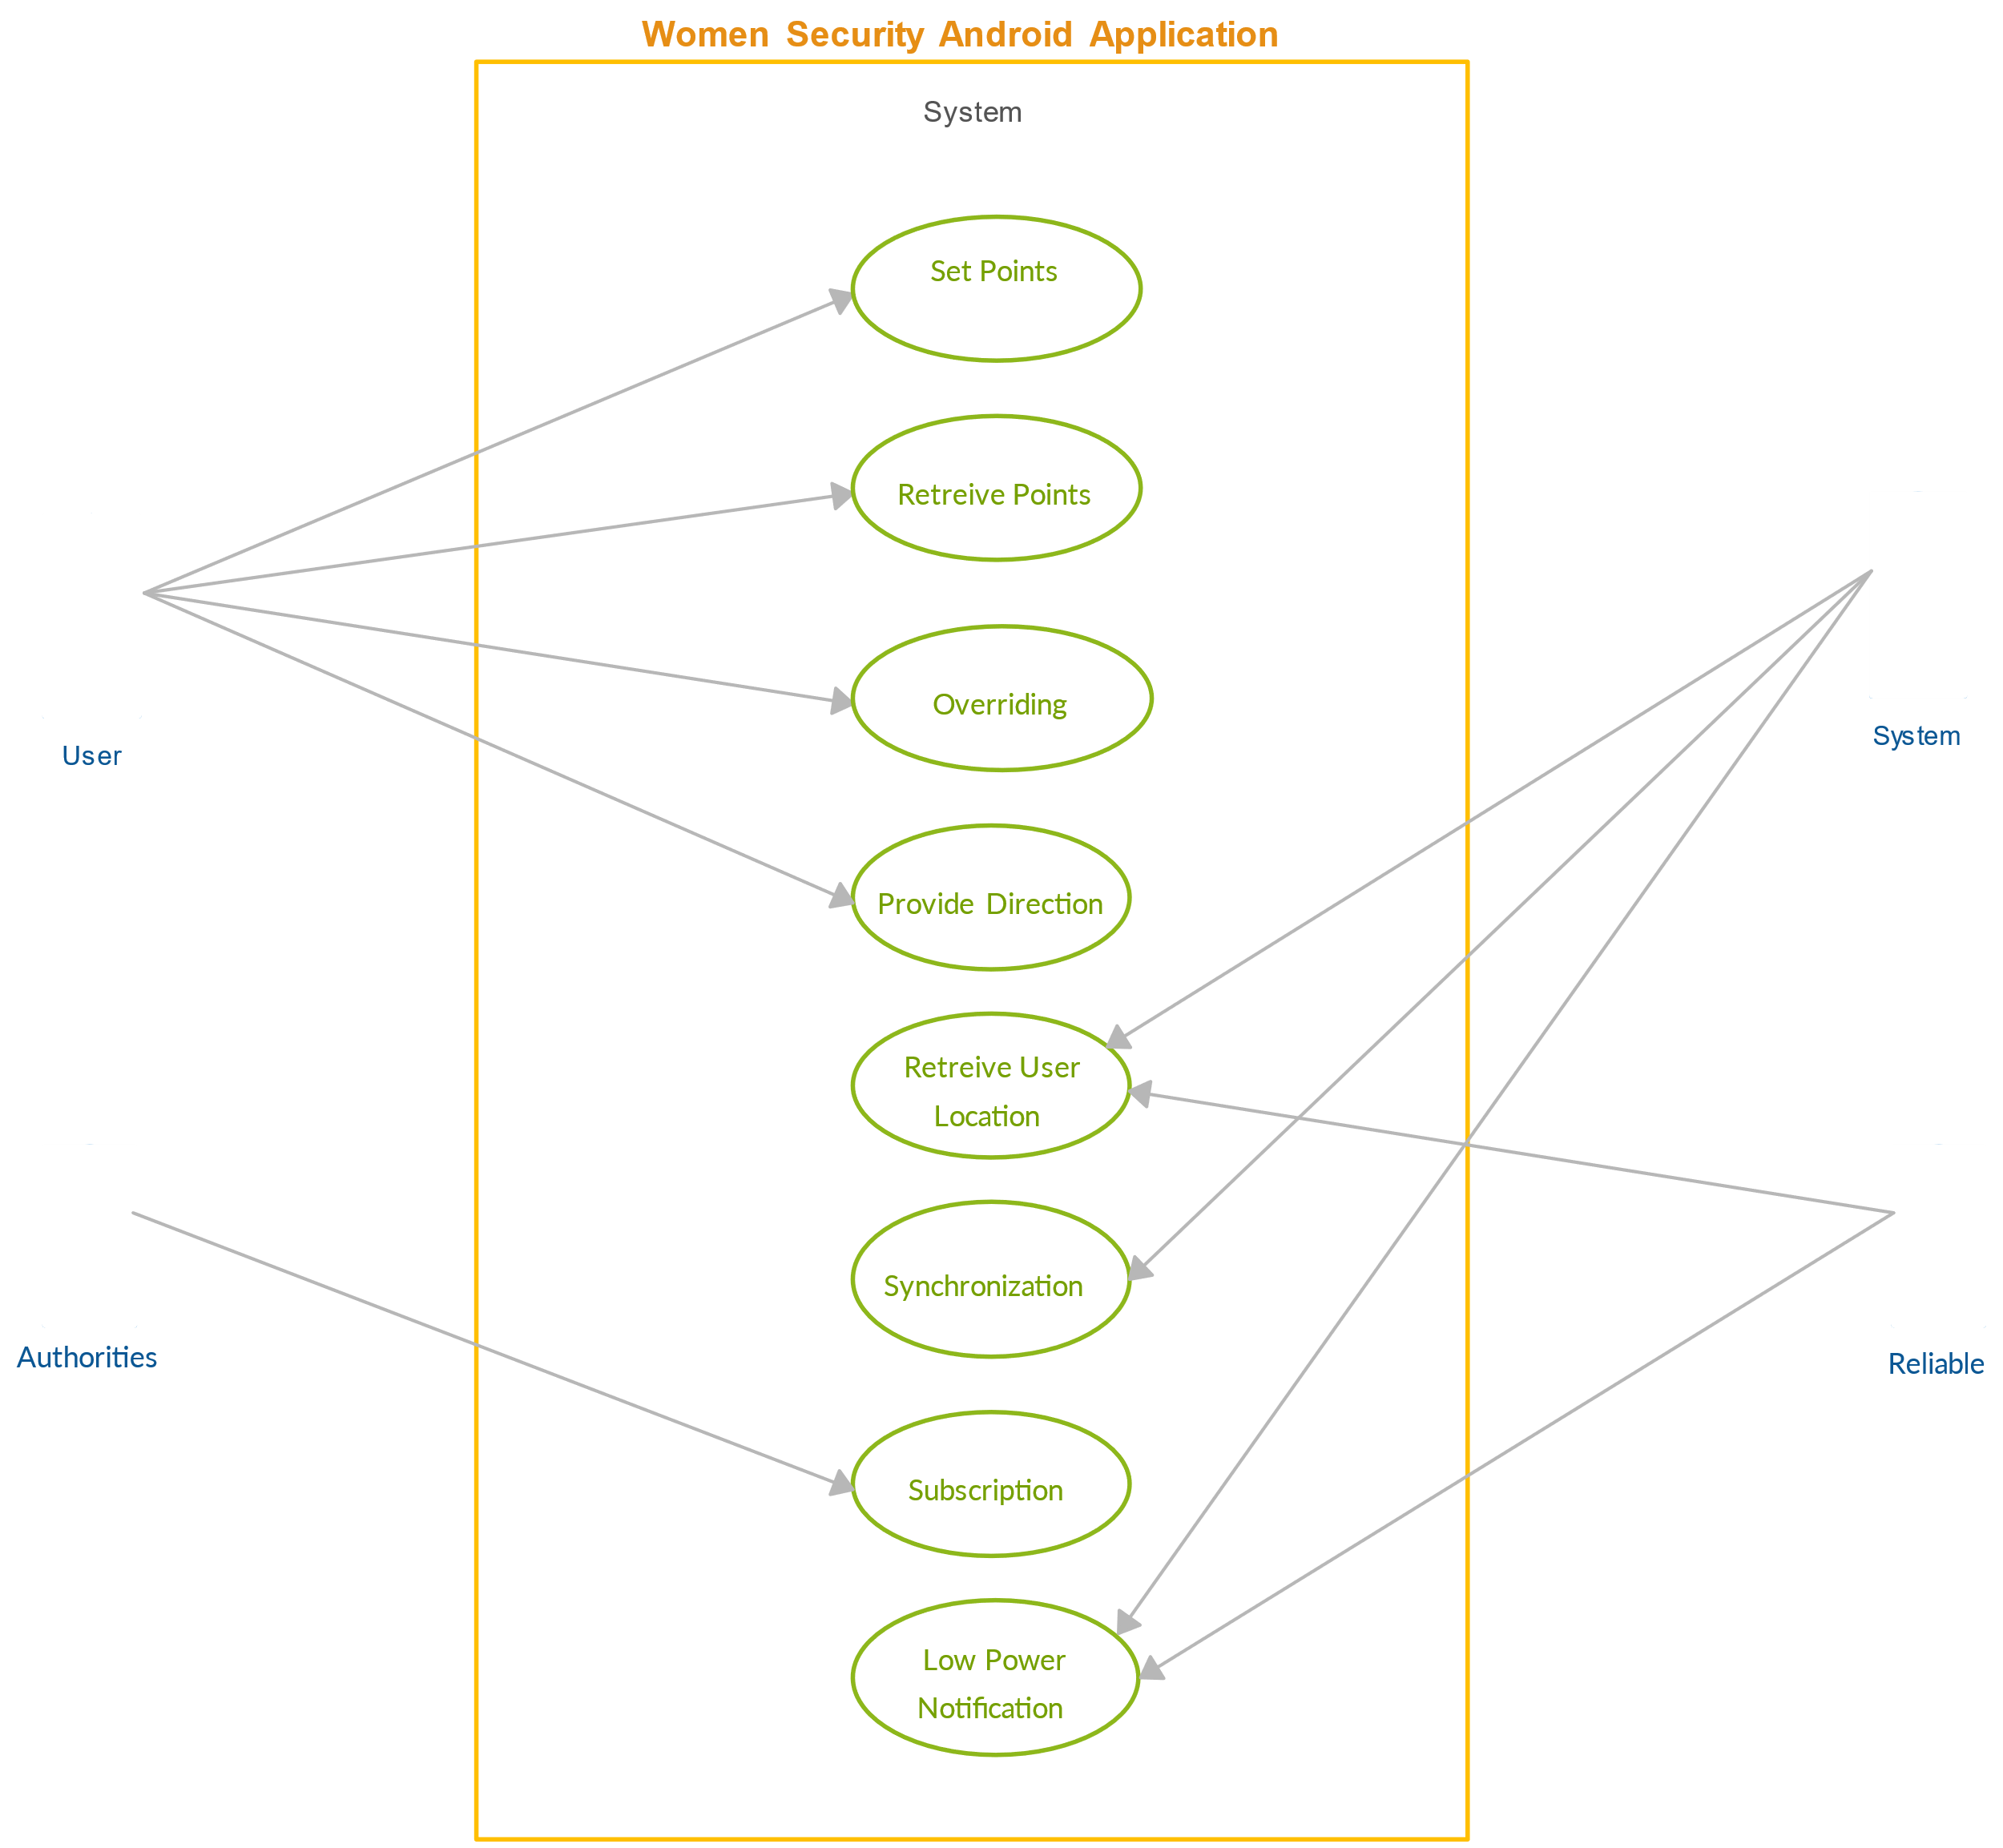

Department of Computer Science and Engineering(AIML) 14

ACE ENGINEERING COLLEGE

6.1.2.Sequence Diagram

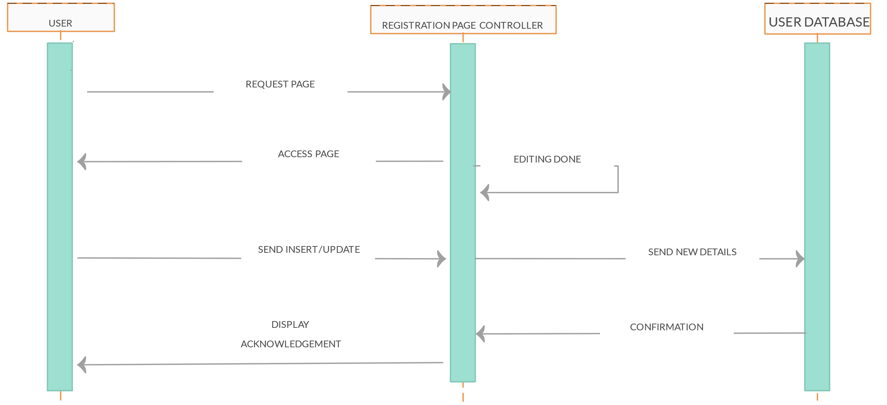

Department of Computer Science and Engineering(AIML) 15

ACE ENGINEERING COLLEGE

6.1.3.Class Diagram

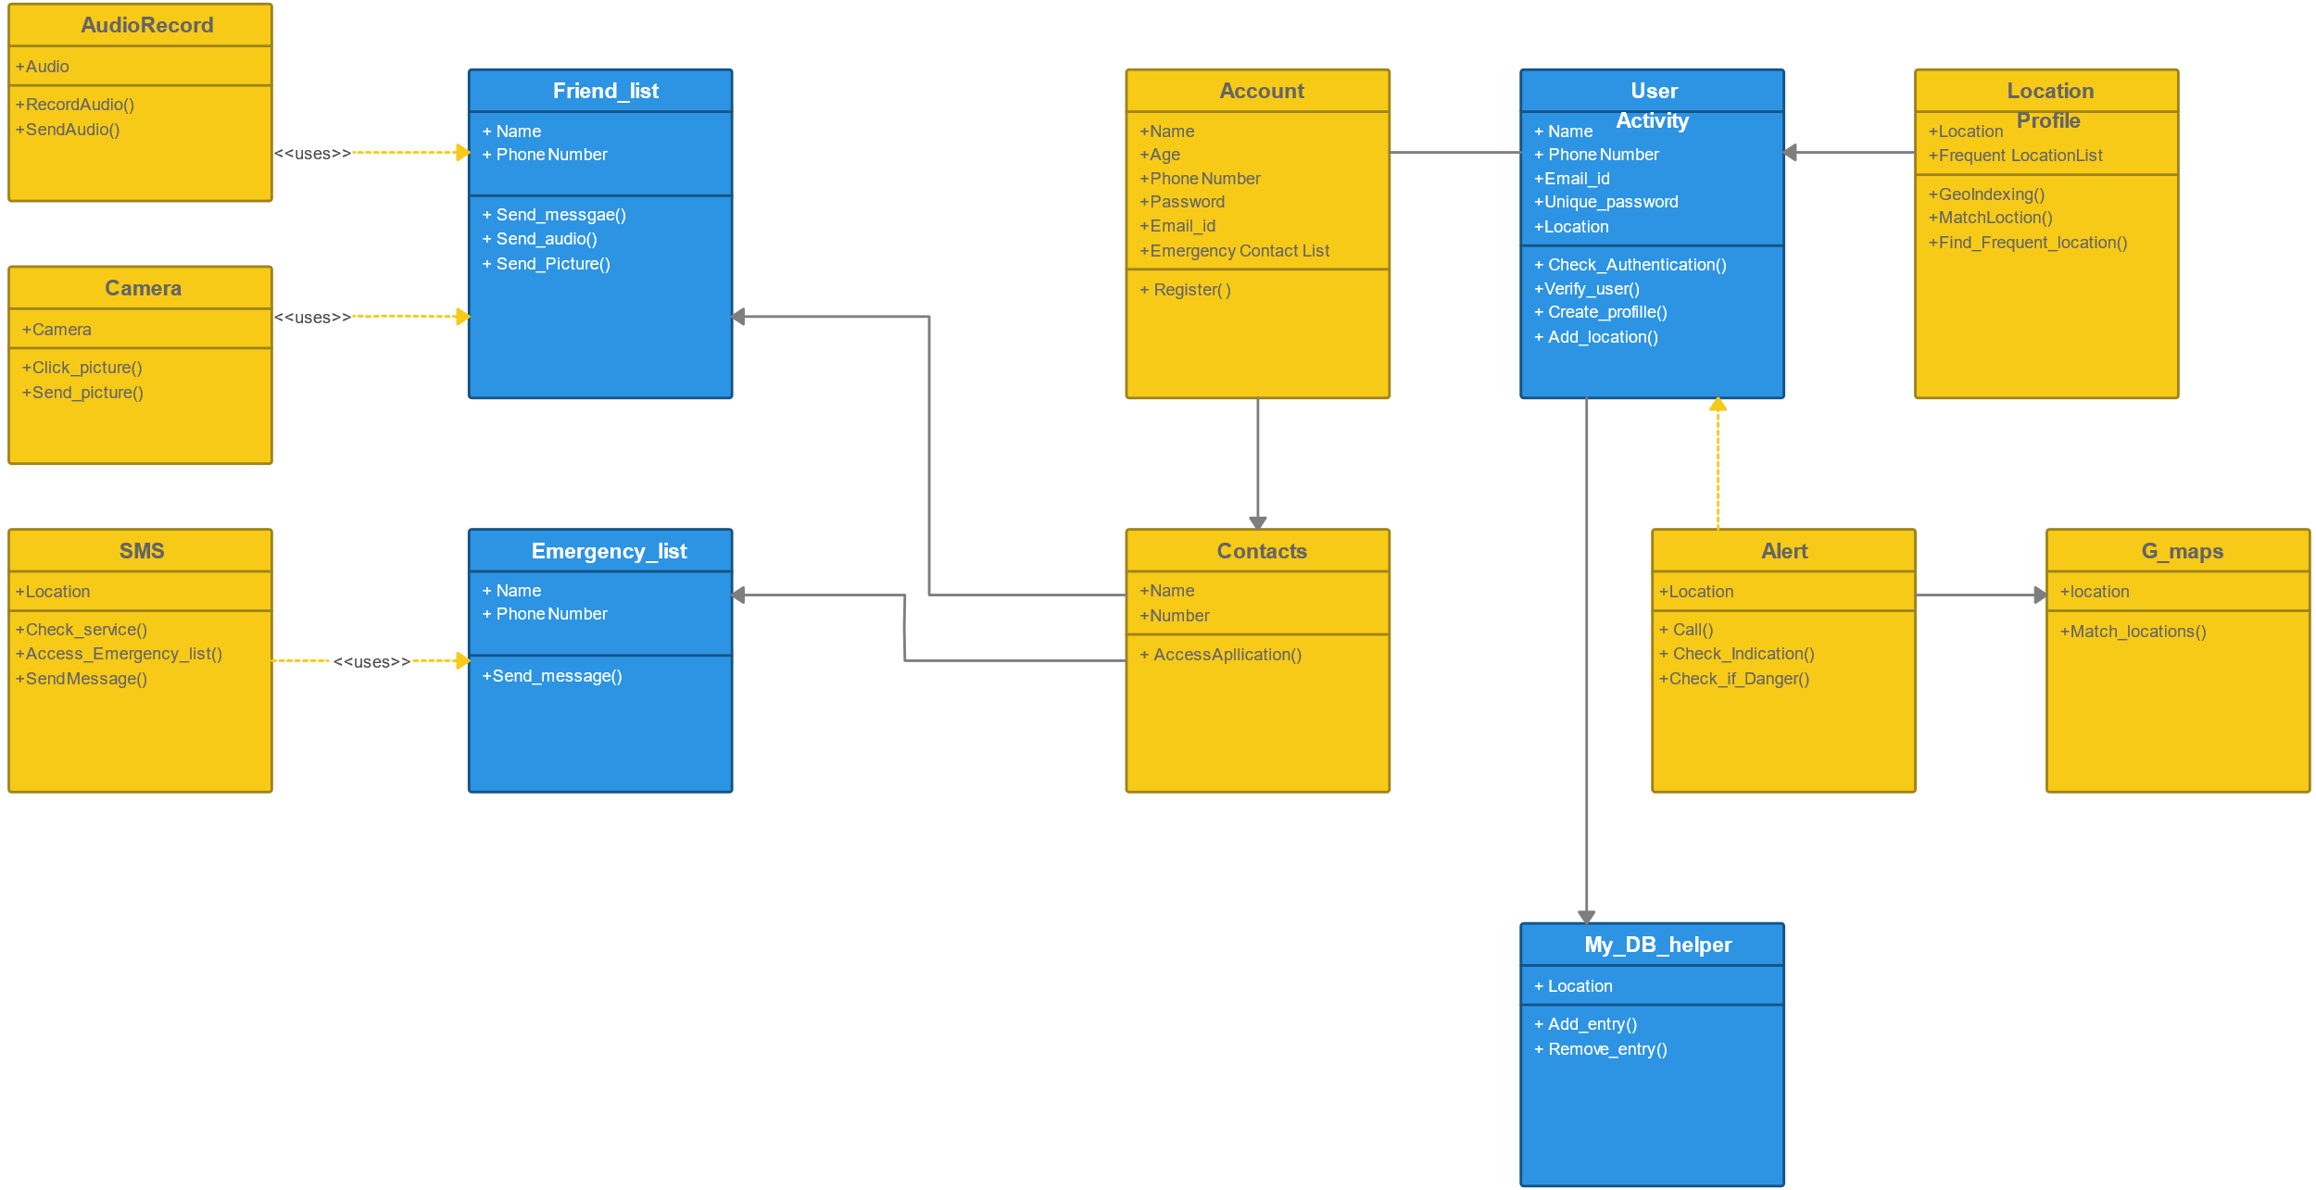

Department of Computer Science and Engineering(AIML) 16

ACE ENGINEERING COLLEGE

6.2.Flow Charts

6.2.1 Flow chart-Track me

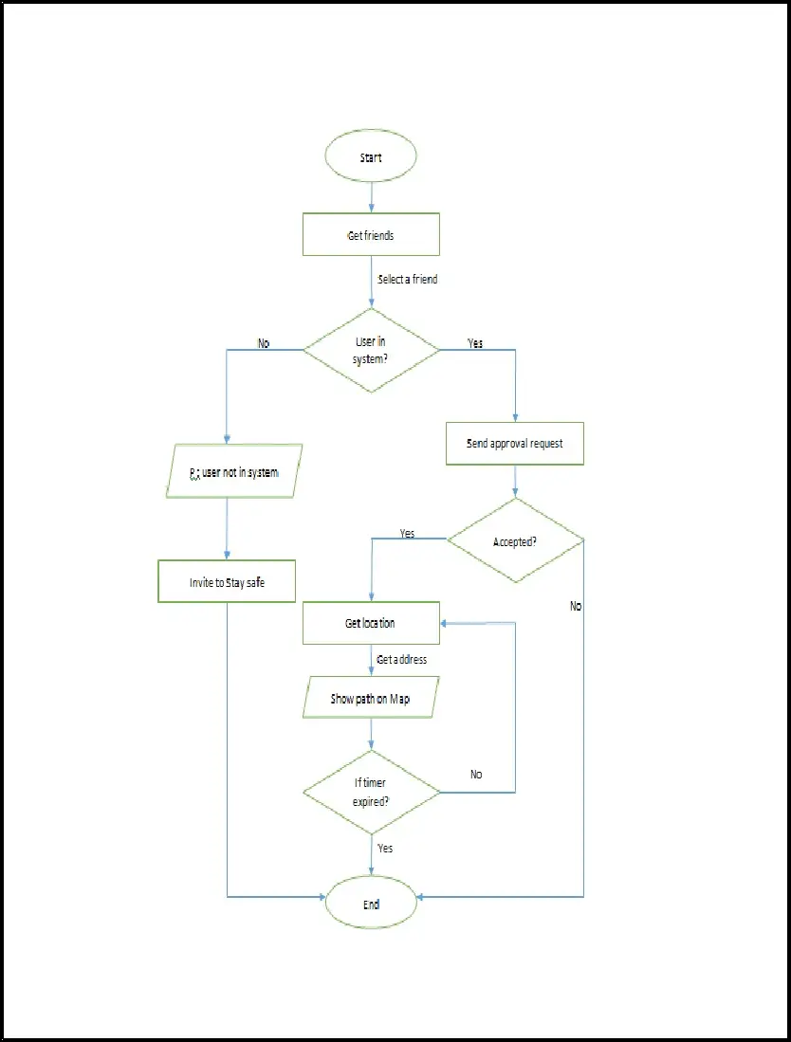

Department of Computer Science and Engineering(AIML) 17

ACE ENGINEERING COLLEGE

6.2.2 Flow chart-Where are you?

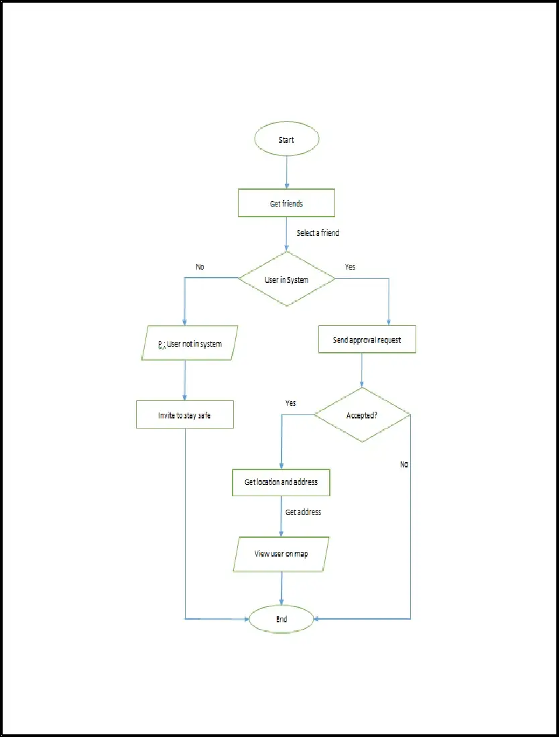

Department of Computer Science and Engineering(AIML) 18

ACE ENGINEERING COLLEGE

6.2.3 Flow chart-Distress signals(SOS)

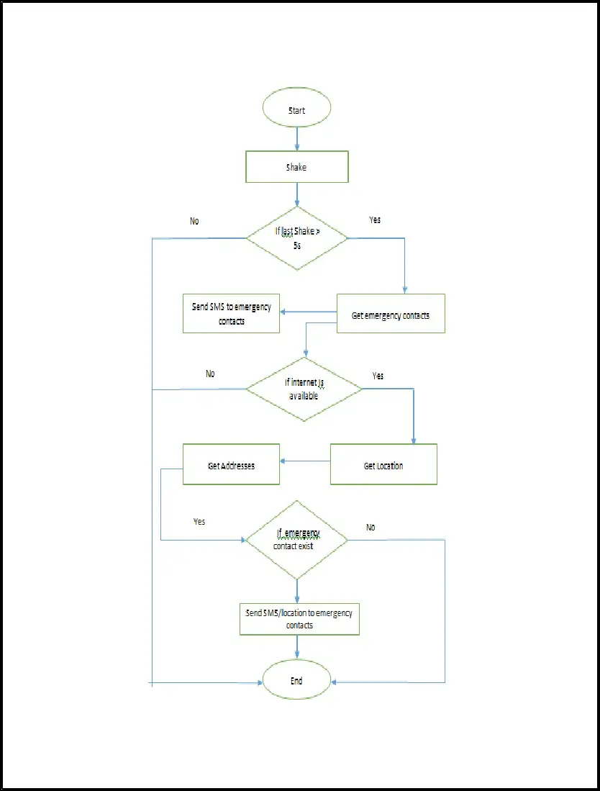

Department of Computer Science and Engineering(AIML) 19

ACE ENGINEERING COLLEGE

CHAPTER 7

TESTING

Testing in a women's safety project typically involves evaluating the effectiveness, reliability, and usability of various safety measures and technologies designed to enhance the safety and security of women.

**Safety Measures Evaluation**: Testing involves assessing the efficacy of safety measures such as panic buttons, emergency response systems, surveillance cameras, and safety apps. This includes testing how quickly and effectively these measures can be accessed and utilized during an emergency.

**Technological Solutions Testing**: Women's safety projects often incorporate technology such as mobile apps, wearable devices, and smart sensors. Testing focuses on verifying the functionality, reliability, and user-friendliness of these technologies in real-world or simulated scenarios.

**Usability and Accessibility Testing**: It's crucial that safety tools and technologies are easy to use and accessible to a diverse range of users. Testing involves evaluating the user interface (UI) and user experience (UX) to ensure intuitive operation and clear communication of safety features.

**Security and Privacy Testing**: Given the sensitive nature of women's safety, testing also includes assessing the security measures implemented in technologies to protect user data and ensure privacy. This may involve vulnerability assessments, penetration testing, and compliance with data protection regulations.

Department of Computer Science and Engineering(AIML) 20

ACE ENGINEERING COLLEGE

7.1.Functional Testing

Functional testing in a women safety project involves verifying that all the functionalities or features of the application or system work as expected in the context of ensuring safety for women.

**Feature Testing**: Ensure that all the specific features designed to enhance women's safety are working correctly. This could include panic buttons, GPS tracking, emergency contact alerts, etc.

**User Interface Testing**: Check the usability and accessibility of the interface. It's important that users can easily navigate and utilize safety features in stressful situations.

**Integration Testing**: Verify that different modules or components of the system work together seamlessly. For example, ensuring that the panic button triggers the correct alert messages and activates location tracking accurately.

**Performance Testing**: Test the system under expected loads to ensure it responds efficiently during emergencies. This includes checking response times for alerts and GPS accuracy.

**Security Testing**: Validate that the system is secure against unauthorized access and data breaches. This is crucial for protecting the sensitive information that might be collected during emergency situations.

**Accessibility Testing**: Verify that the application meets accessibility standards, ensuring that it can be used effectively by all potential users, including those with disabilities.

Department of Computer Science and Engineering(AIML) 21

ACE ENGINEERING COLLEGE

7.2.Structural Testing

Structural testing in a women safety project focuses on examining the internal structure of the software application or system to ensure that it functions correctly and securely, especially in the context of providing safety features for women. This type of testing is concerned with verifying the behavior of the software at a lower level, typically involving code and internal components.

**Code Coverage Analysis**: Ensure that the tests cover a sufficient portion of the codebase related to critical safety functionalities. This helps in identifying any untested or poorly tested areas that could potentially lead to vulnerabilities.

**Unit Testing**: Test individual units or modules of code to verify their correctness. For a women safety project, this might involve testing specific functions such as GPS tracking algorithms, data encryption methods, or communication protocols used during emergencies.

**Integration Testing**: Verify the interaction between different modules or components to ensure they work together as expected. This could include testing how the panic button module communicates with the alert notification system or how location data is passed between different parts of the application.

Department of Computer Science and Engineering(AIML) 22

ACE ENGINEERING COLLEGE

**Security Testing**: Conduct tests to identify and address potential security vulnerabilities within the software. This includes checking for secure coding practices, input validation, and resistance to common security threats such as SQL injection or cross-site scripting (XSS) attacks.

**Performance Testing**: Evaluate the performance of critical components related to safety features, such as response times for emergency alerts, GPS accuracy under various conditions, and the system's ability to handle simultaneous requests during peak usage.

**Load Testing**: Test the system's ability to handle a large number of simultaneous users or requests, especially during emergency situations when the load on the system might increase significantly.

**Compliance Testing**: Ensure that the software complies with relevant regulations, standards, and guidelines related to data privacy, security, and emergency response protocols specific to women's safety.

Department of Computer Science and Engineering(AIML) 23

ACE ENGINEERING COLLEGE

CHAPTER 8

IMPLEMENTATION

Implementation in a women safety project involves translating the design and planning phases into actual software or system that incorporates various safety features and functionalities aimed at enhancing the security and well-being of women

**Feature Development**: Implementing specific safety features such as panic buttons, GPS tracking, emergency contact alerts, safe routing options, real-time communication channels, and incident reporting mechanisms.

**User Interface (UI) Design**: Designing an intuitive and user-friendly interface that allows women to easily access and utilize safety features during emergencies or unsafe situations. This includes ensuring accessibility and ease of use under stressful conditions.

**Backend Development**: Developing the backend infrastructure that supports the functionalities of the application, such as data storage, processing of emergency alerts, handling communication between different components, and ensuring scalability and reliability.

**Integration of Technologies**: Integrating various technologies such as GPS, messaging services, emergency services APIs, and data encryption methods to ensure robust and secure functionality of the safety features.

**Security Implementation**: Implementing stringent security measures to protect sensitive user data, ensure secure communication channels, prevent unauthorized access, and comply with data protection regulations.

Department of Computer Science and Engineering(AIML) 24

ACE ENGINEERING COLLEGE

**Testing and Quality Assurance**: Conducting thorough testing, including functional testing, structural testing, security testing, performance testing, and user acceptance testing (UAT), to ensure that the implemented features work as expected and meet the safety requirements.

**Localization and Cultural Sensitivity**: Adapting the implementation to different geographical locations and cultural contexts to ensure that safety features are relevant and effective for the target user demographics.

**Deployment and Maintenance**: Deploying the application or system in production environments and ensuring ongoing maintenance and updates to address issues, add new features, and improve performance based on user feedback and evolving safety needs.

**Monitoring and Evaluation**: Implementing mechanisms to monitor the effectiveness of the safety features, gather feedback from users, and continuously evaluate and improve the system based on real-world usage and incidents.

Department of Computer Science and Engineering(AIML) 25

ACE ENGINEERING COLLEGE

CHAPTER 9

USER MANUAL

Creating a user manual for a women safety project is crucial to ensure that users understand how to effectively utilize the features and functionalities designed to enhance their safety.

**Project Overview**: Provide a brief introduction to the women safety project, its objectives, and the importance of the safety features provided.

**Target Audience**: Specify who the manual is intended for (e.g., users, administrators, support staff).

**System Requirements**: Outline the hardware and software requirements needed to use the application (e.g., compatible devices, operating systems).

**Installation Instructions**: If applicable, provide step-by-step instructions on how to download and install the application from app stores or other sources.

**Interface Navigation**: Describe the layout of the user interface (UI), highlighting key elements such as buttons, menus, and icons related to safety features.

**Accessibility Features**: Explain any accessibility options available to ensure inclusivity

**Panic Button**: Provide detailed instructions on how to activate the panic button, including any requirements (e.g., long press, confirmation).

Department of Computer Science and Engineering(AIML) 26

ACE ENGINEERING COLLEGE

**Emergency Contacts**: Explain how users can set up and manage emergency contacts within the application.

**GPS Tracking**: Describe how GPS tracking works, how to enable it, and what information is shared during emergencies.

**Safe Routing**: If applicable, explain how users can plan safe routes and utilize navigation features tailored for safety.

**Alert Notifications**: Detail how users receive and respond to alert notifications, including audible alerts, vibrations, and on-screen prompts.

**Step-by-Step Guides**: Provide detailed, step-by-step guides for common scenarios such as:

* Activating an emergency alert
* Sending location updates to emergency contacts
* Reporting incidents through the application

**Troubleshooting Tips**: Include troubleshooting tips for common issues users may encounter (e.g., connectivity problems, GPS accuracy issues).

**Closing Remarks**: Conclude with a brief message thanking users for using the application and reiterating the commitment to their safety and satisfaction.

Department of Computer Science and Engineering(AIML) 27

ACE ENGINEERING COLLEGE

CHAPTER 10

APPENDIX

**Android Apps**: Java is the official language for Android app development. Women safety applications can be developed using Java for Android devices, incorporating features like panic buttons, GPS tracking, emergency alerts, and communication functionalities.

Java’s strong security features and libraries make it suitable for implementing encryption algorithms to secure user data, communications, and sensitive information transmitted within the women safety application.

Provides practical safety tips and guidelines tailored specifically for women, covering various scenarios such as walking alone at night, using public transportation, and interacting with strangers.

Highlights contact information and availability of these resources for easy access in times of need.

Department of Computer Science and Engineering(AIML) 28